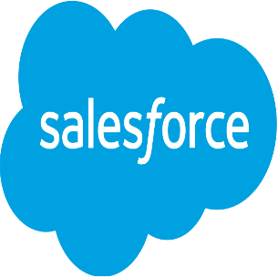

**PROJECT**

**OF**

**SALESFORCE DEVELOPER**

**TO SUPPLY LEFT OVER FOOD TO POOR**

Submitted by

Reetu Singh

Roll Number: 0905cs211139

ITM GOI , GWALIOR

Email I’d: [reetu6842@gmail.com](mailto:reetu6842@gmail.com)

**Project Abstract**

This project aims to address food waste and hunger by leveraging Salesforce technology to efficiently distribute surplus food to those in need. The system was developed to connect restaurants, grocery stores, and food suppliers with non-profit organizations and shelters. The Salesforce platform serves as the backbone of this initiative, enabling real-time tracking of food donations, managing logistics, and ensuring timely delivery to recipients.

The application utilizes Salesforce's robust CRM capabilities to maintain a network of donors and recipients, automating the matching process based on location, food type, and urgency. Custom objects and workflows were created to handle the intricate logistics involved in food distribution, from donation alerts to final delivery confirmations. Additionally, integration with mobile devices allows field agents to update statuses and track deliveries on the go, ensuring transparency and accountability throughout the process.

By harnessing the power of Salesforce, this project not only reduces food waste but also supports communities in need, creating a sustainable and scalable solution for social good.

**Introduction to Salesforce**

**What is Salesforce?**

Salesforce is a leading cloud-based customer relationship management (CRM) platform that helps businesses manage sales, customer service, and marketing operations. It provides tools for automation, analytics, and customer engagement.

salesforce also offers customization through its AppExchange marketplace and a wide range of integration options. Its scalability and flexibility make it suitable for companies of all sizes across various industries.

Now let’s move to our project:

1. **Salesforce developer account creation**

* Creating a developer org in salesforce
* Account Activation

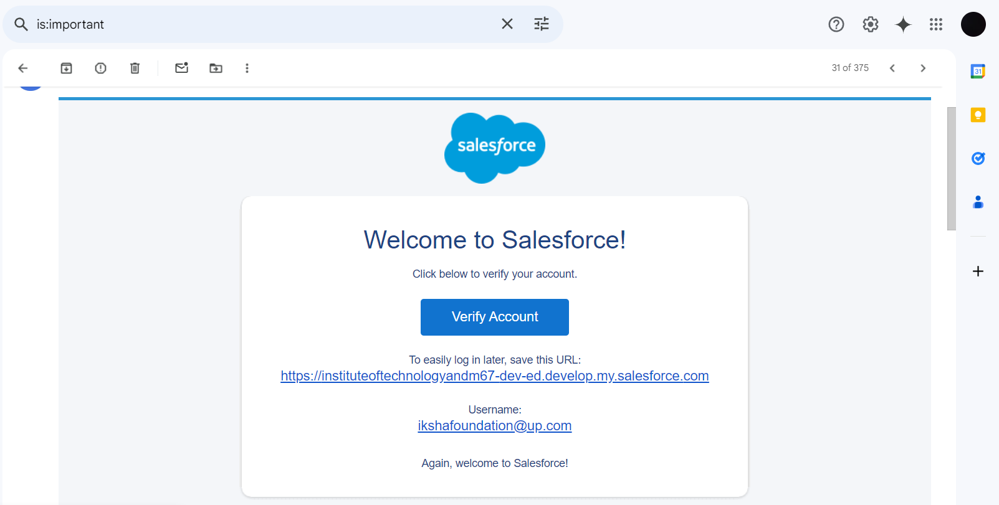

**2. Object**

In Salesforce, an object is a database table that stores data related to a specific entity, such as customers, products, or sales transactions. Objects are the building blocks of Salesforce data models.

There are two types of objects in Salesforce:

1. **Standard Objects:** These are pre-built objects provided by Salesforce, such as Accounts, Contacts, Leads, and Opportunities, which cover common business processes.
2. **Custom Objects:** These are user-defined objects created to store data unique to a particular business or application. Custom objects can have custom fields, relationships, and custom logic through workflows and triggers.

Objects are essential for organizing and managing data within the Salesforce platform.

To create an object:

Here, We have Created All the objects which where asked.

1. Drop-Off Point

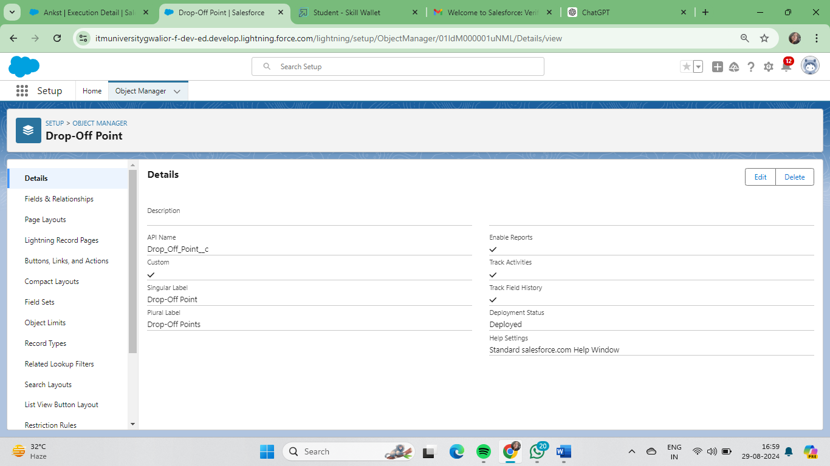

2. Task

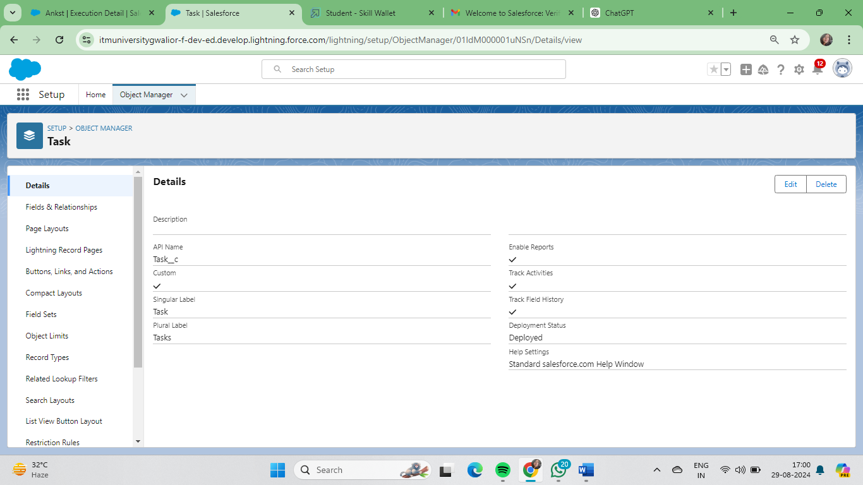

2.. Execution Detail

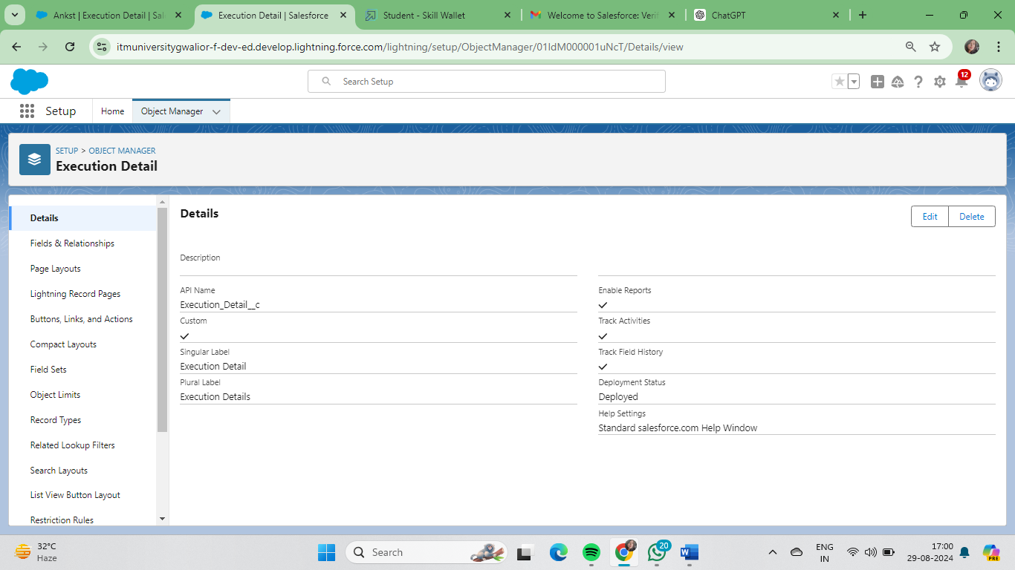

3. Volunteer

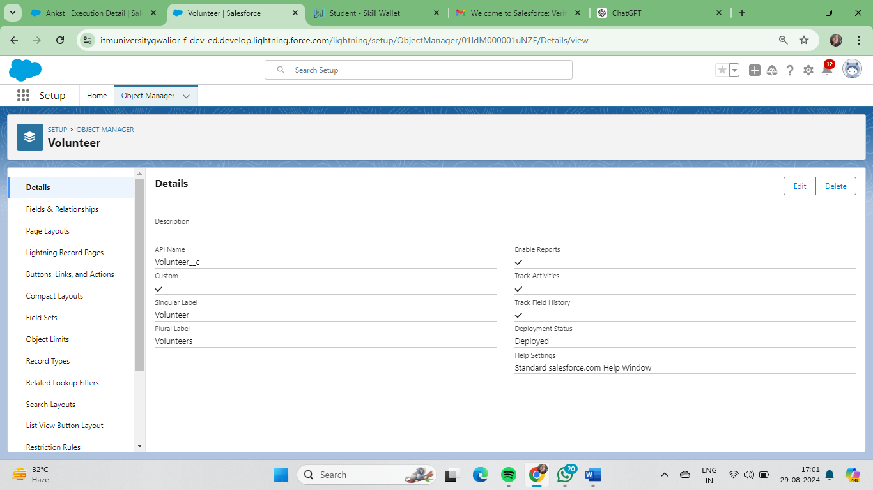

\

5.Venue

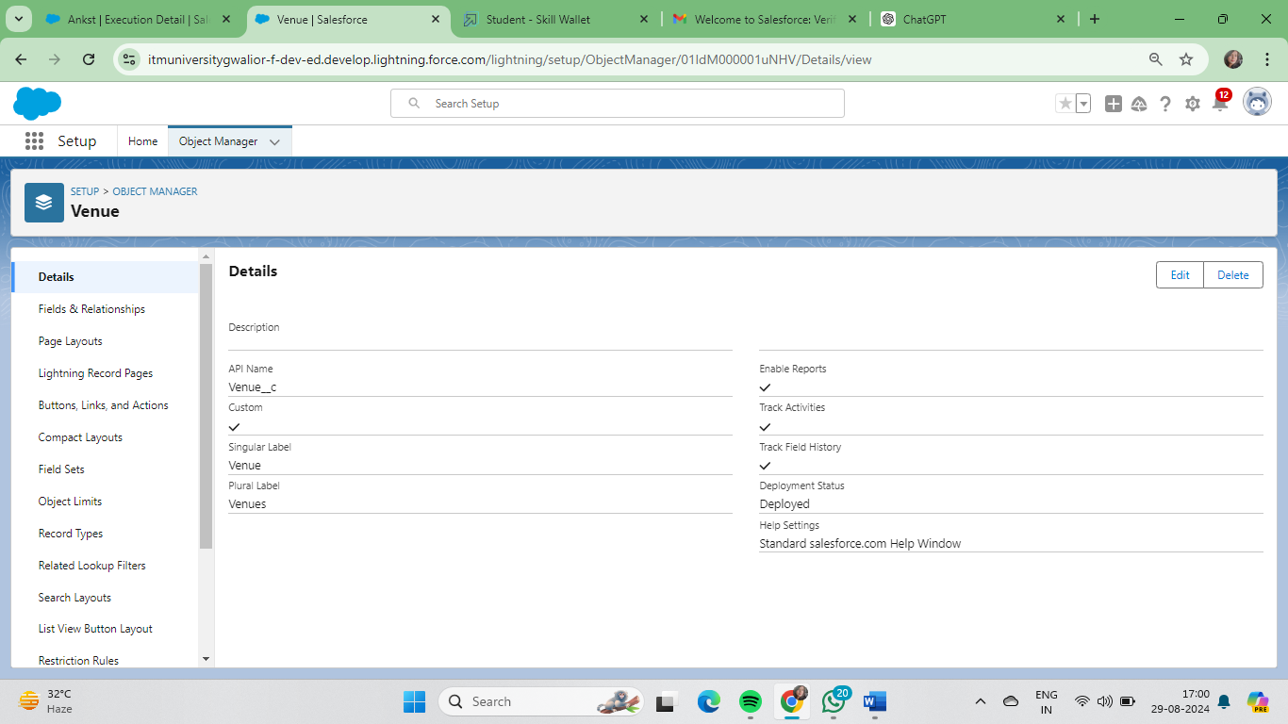

**3. Tabs**

What is Tab ?

 A tab is like a user interface that is used to build records for objects and to view the records in the objects.

* **Creating a Custom Tab**

## Create Venues Tab

I) Drop-Off Point Tab

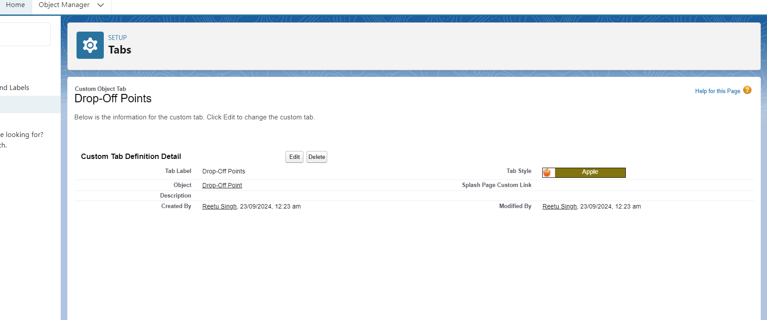

II) Task Tab

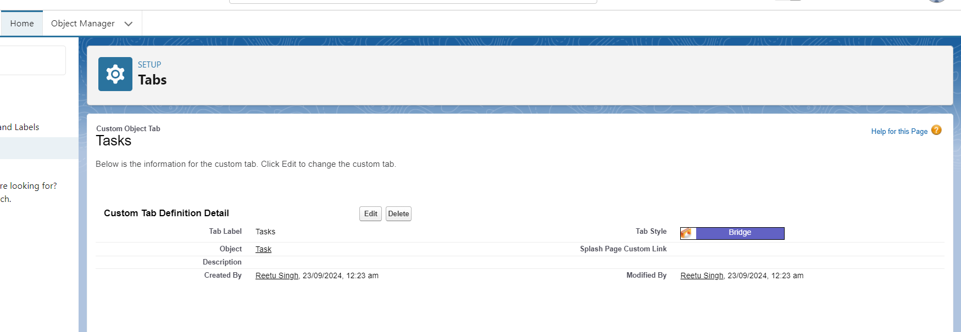

III)  Venues Tab

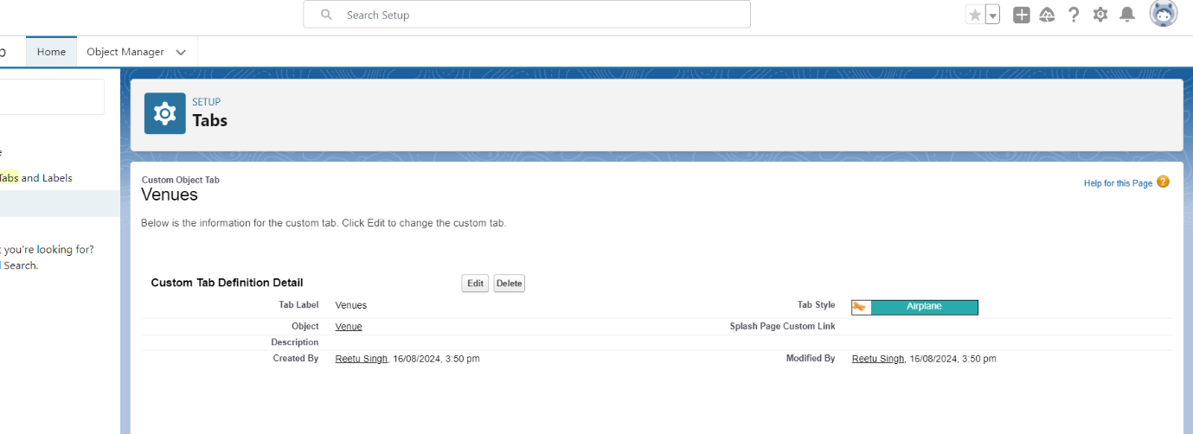

IV) execution Details Tab

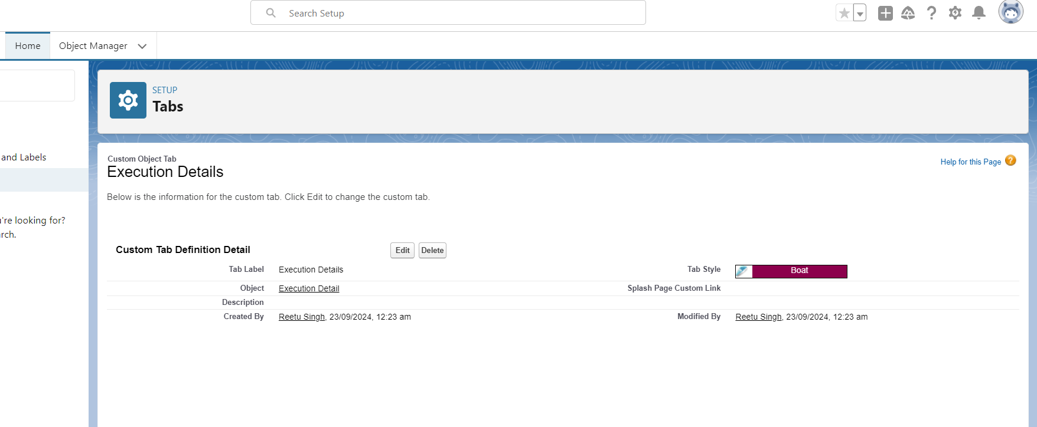

V) Volunteer Tab



**\ Create a Lightning App**

**Will create a lightning app page-**

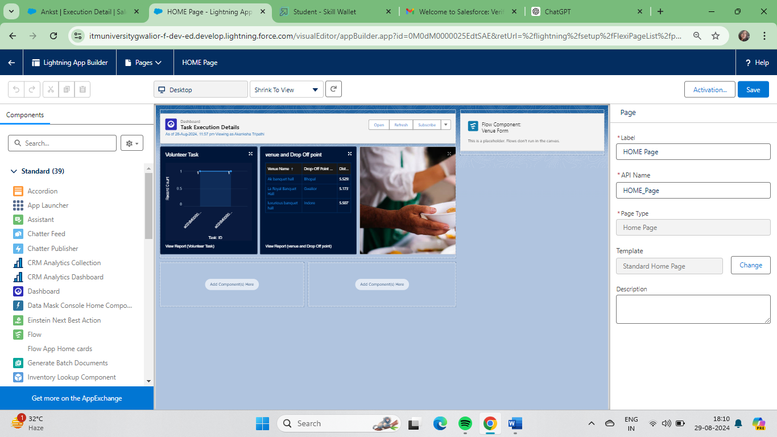

**5. Field**

**What is a Field?**

Fields are specific data points within an object where individual pieces of information are stored. They are akin to columns in a database table and can hold various types of data, such as text, numbers, or dates.

Creation of Fields for the Volunteer Object - Gender

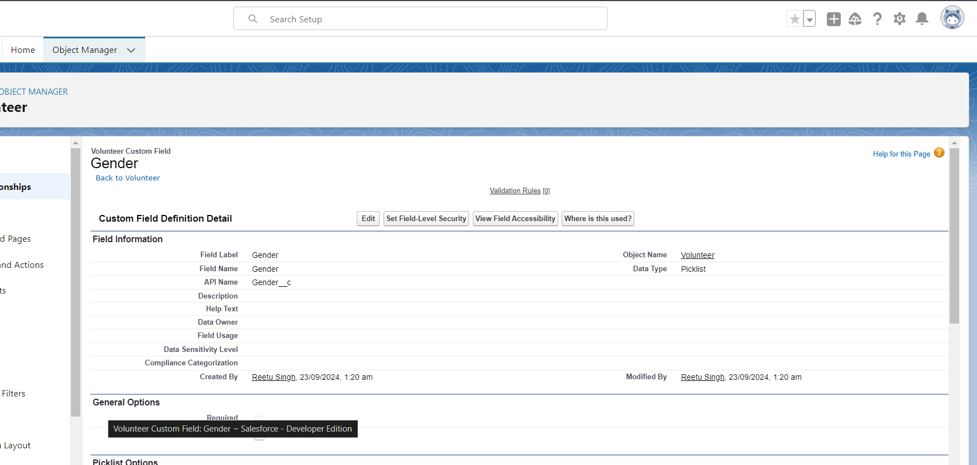

**Execution ID**

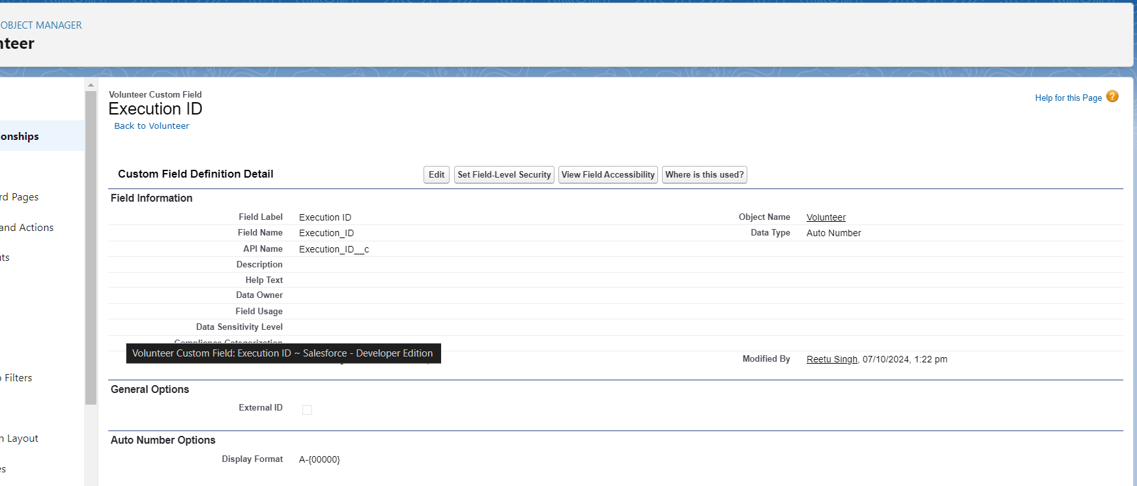

**Date of Birth** 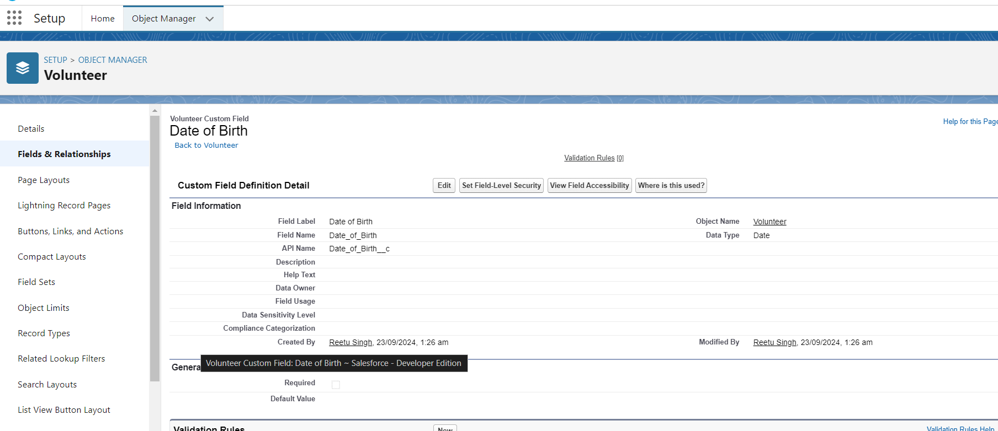

**Address**

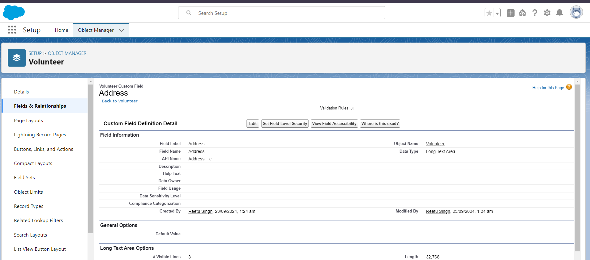

**Contact Number**

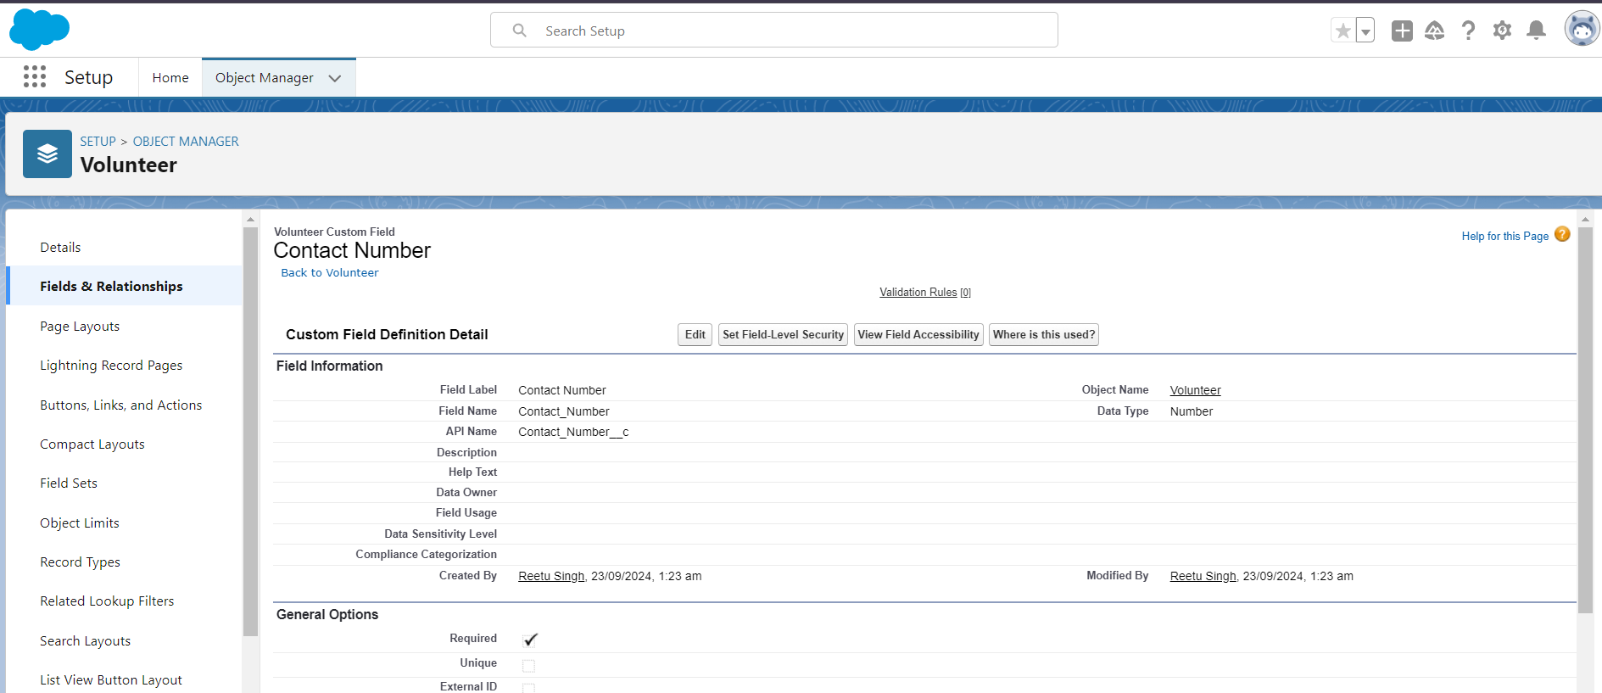

**Email**

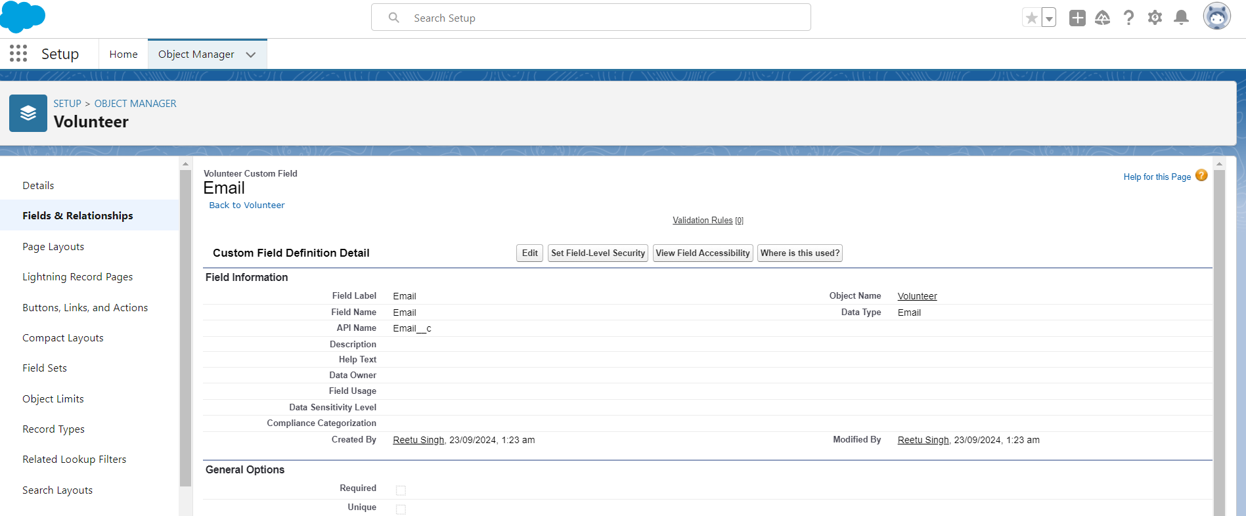

**Age**

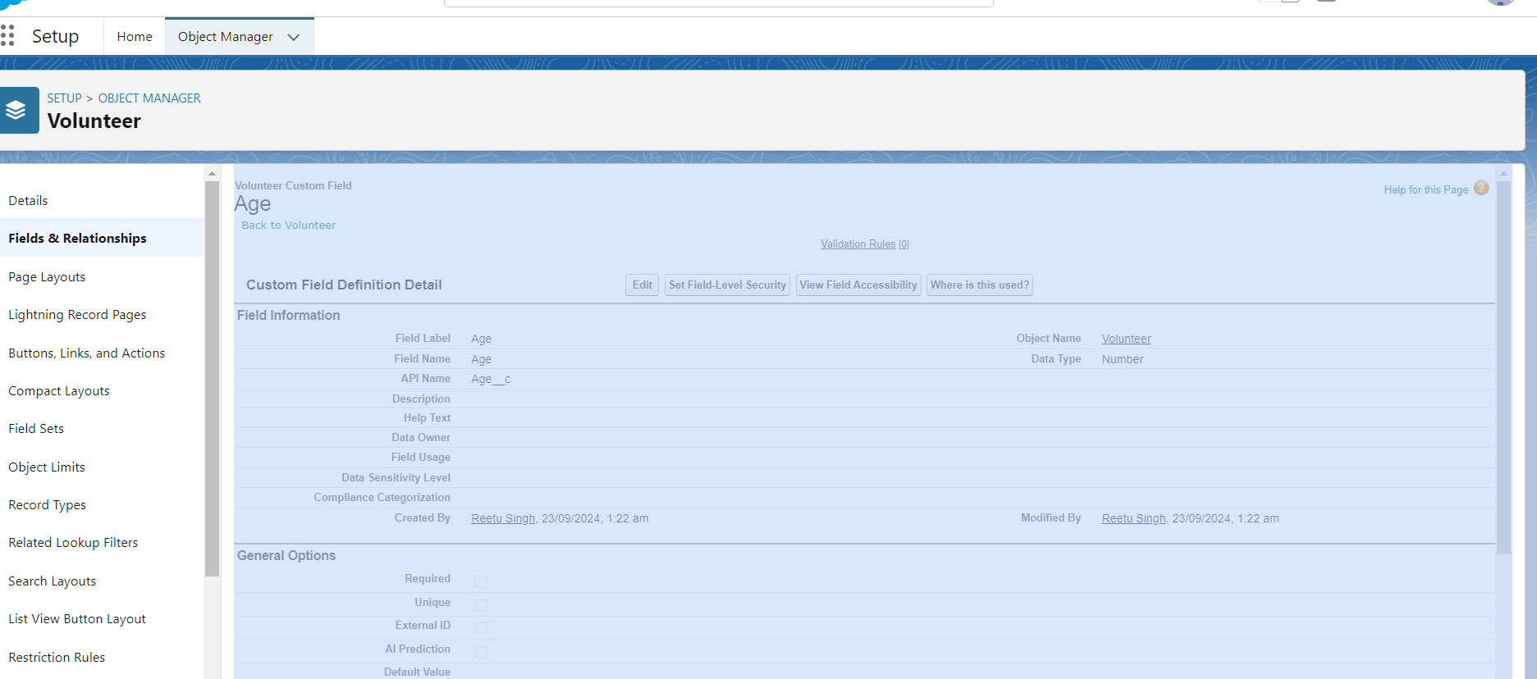

**Available On** 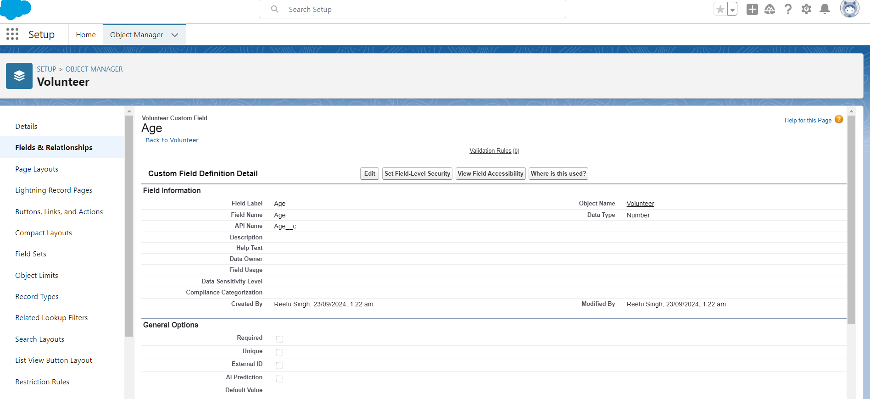

**Volunteer ID** 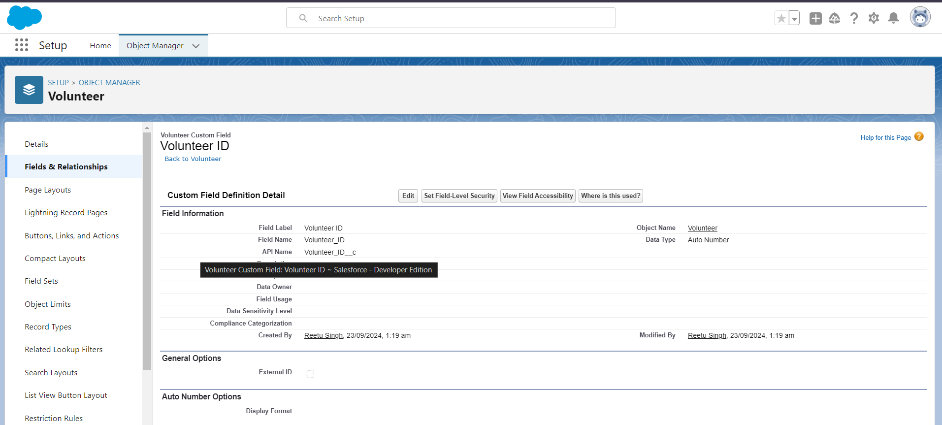

**Drop-Off Point**

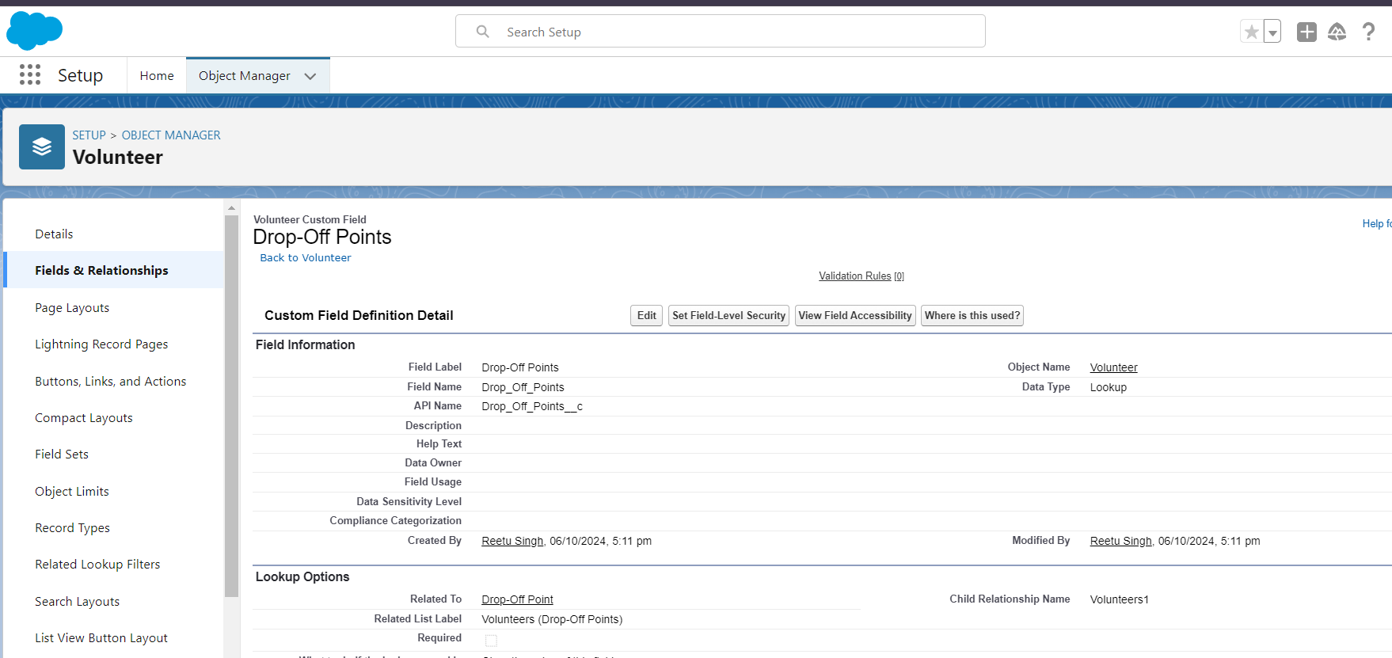

**Creation of Fields for the Venue Object**

**Contact Email**

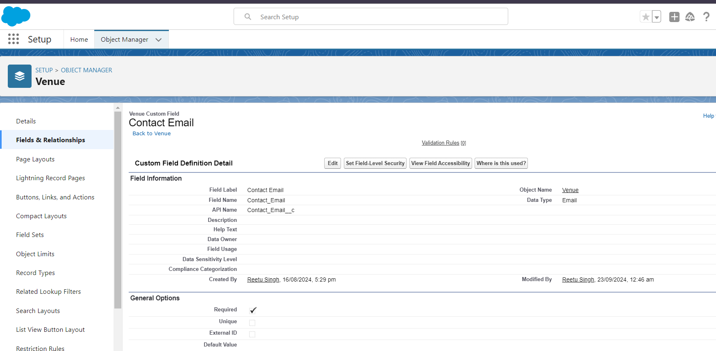

**Contact Phone** 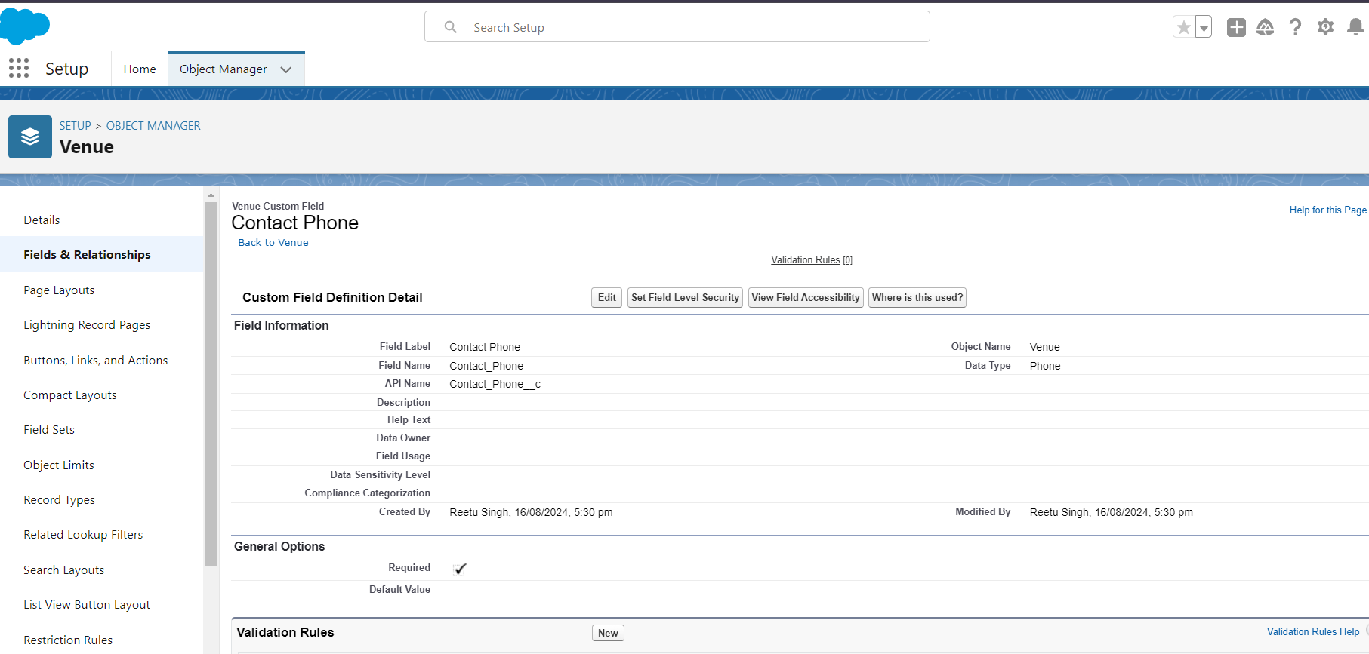

**Location**

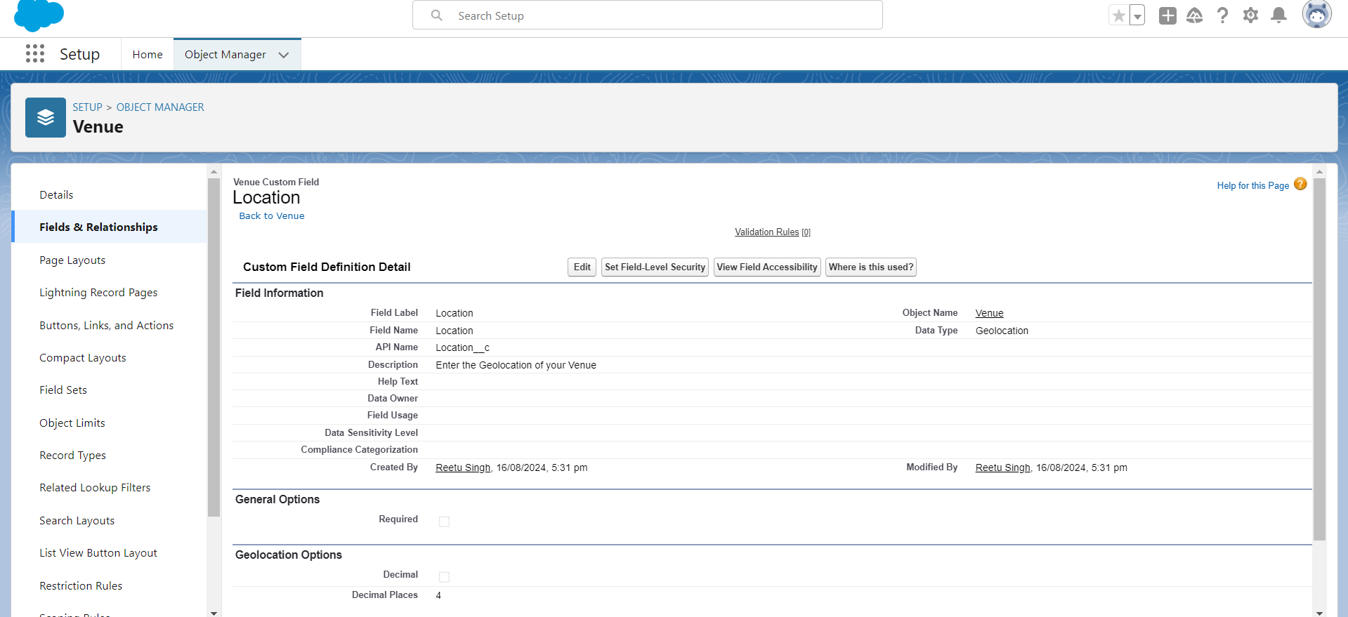

**Venue Location**

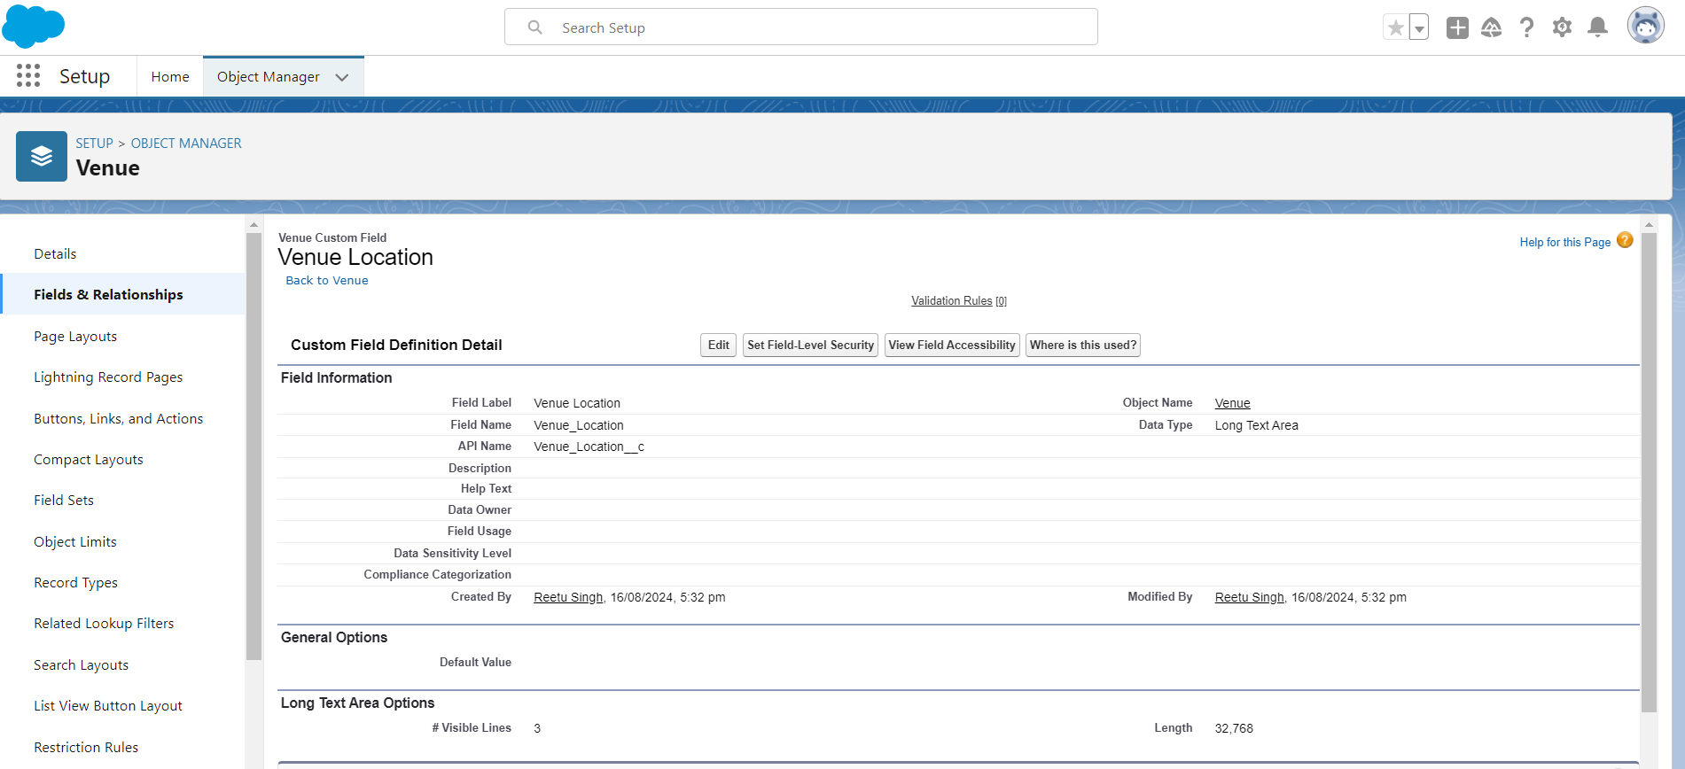

**Creation of Fields for the Drop-Off Point Object**

**Location 2**

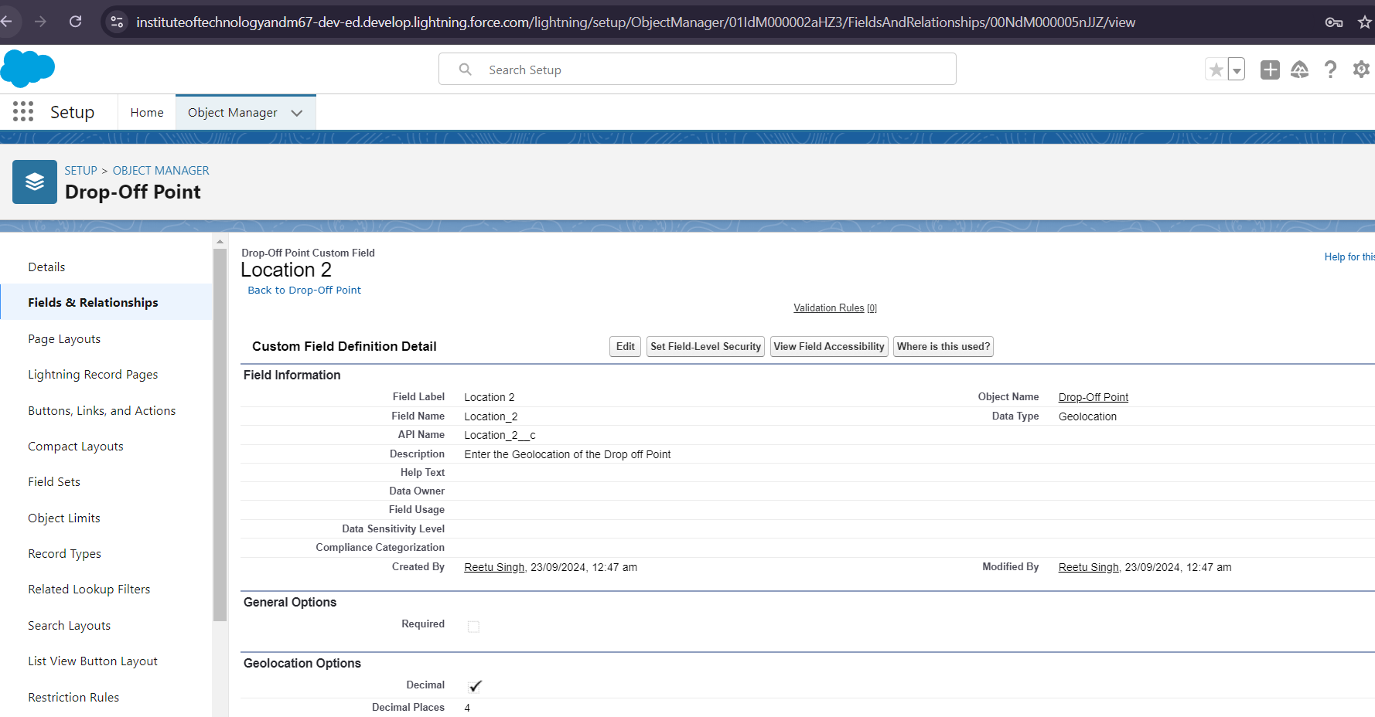

**Distance Calculation**

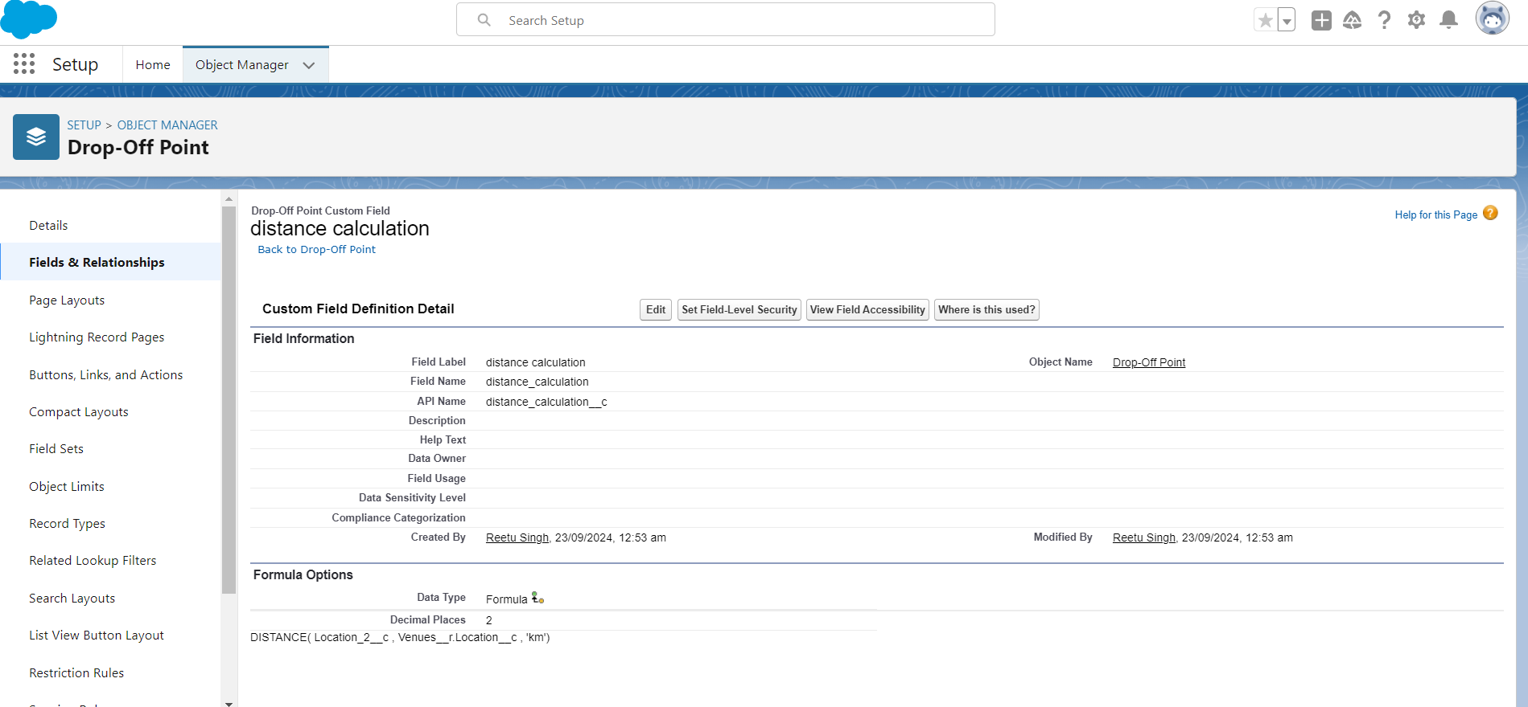

**Creation of Fields for the Task Object**

**Venue_c**

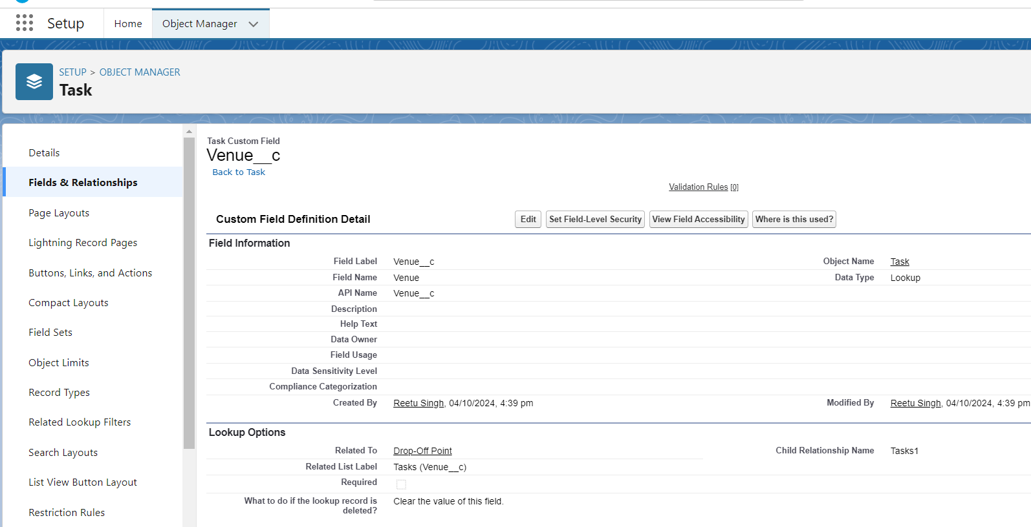

**Feedback**

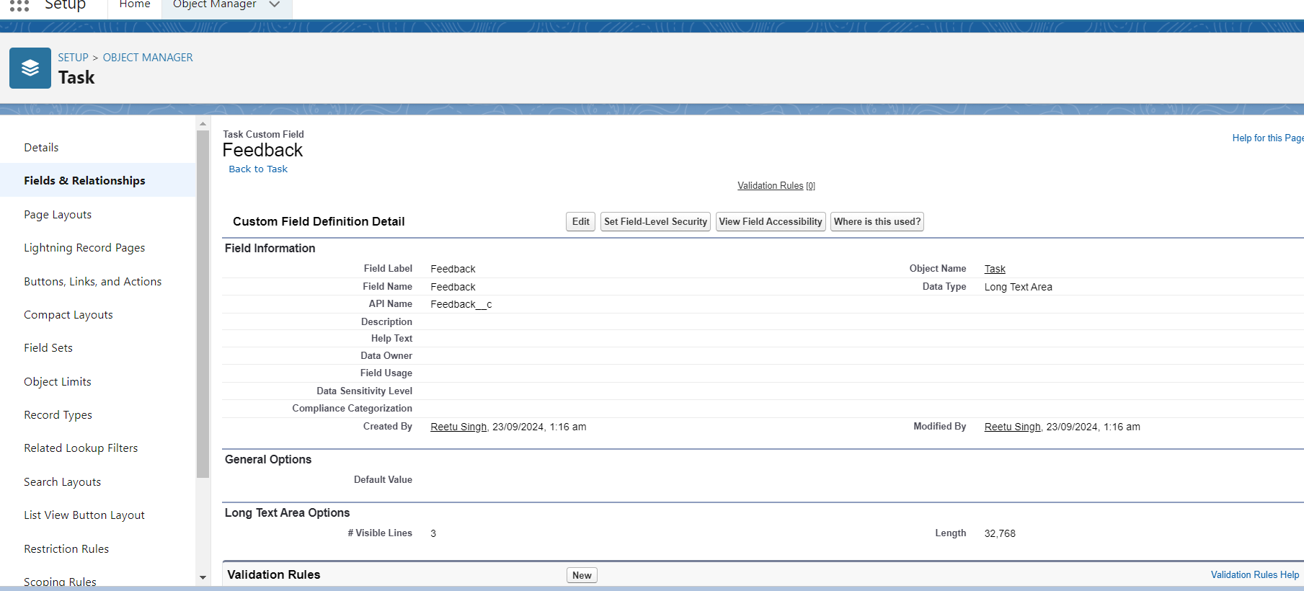

**Rating** 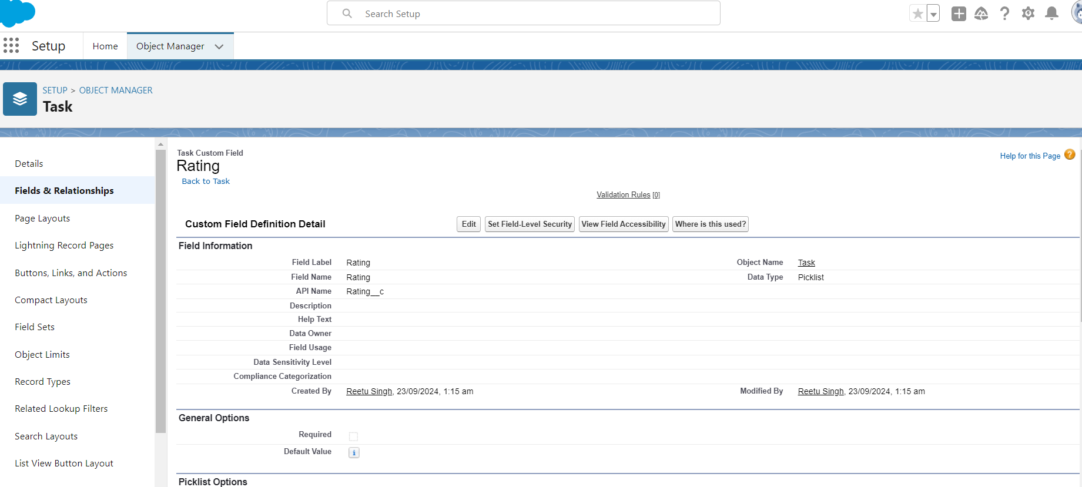

**Phone**

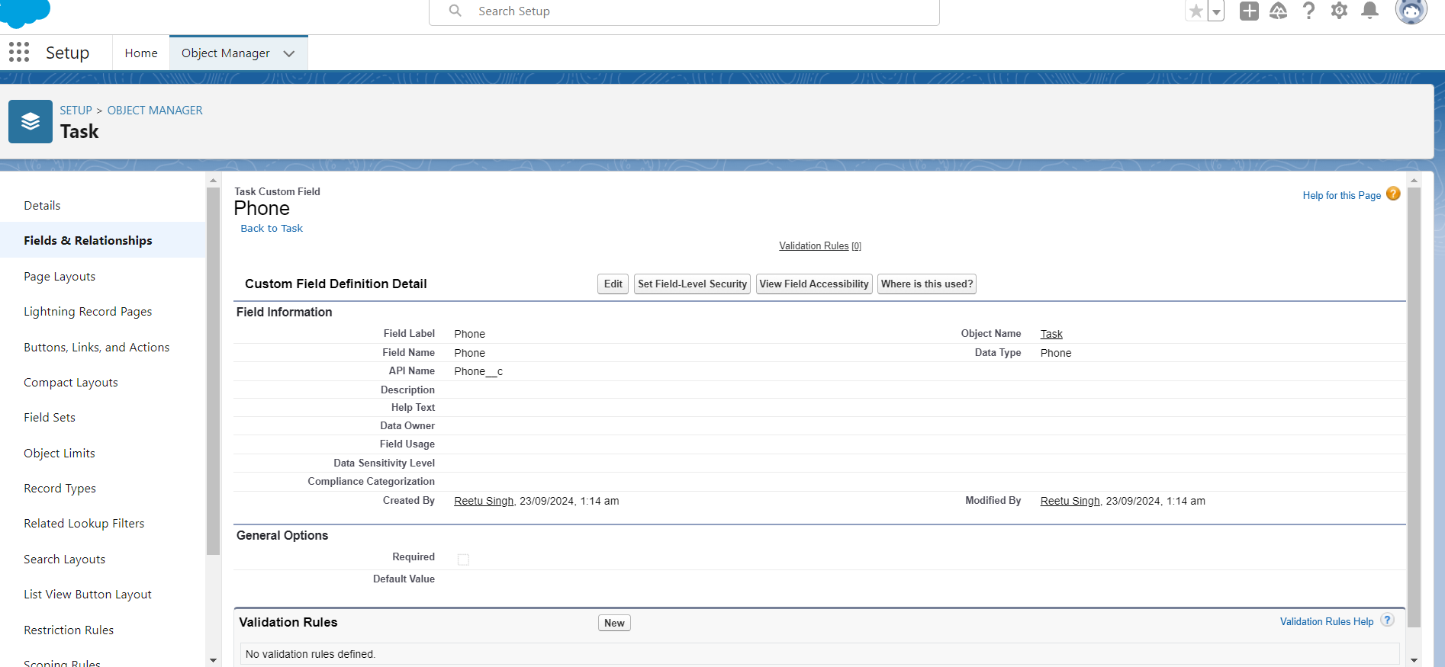

**Name of the Person**

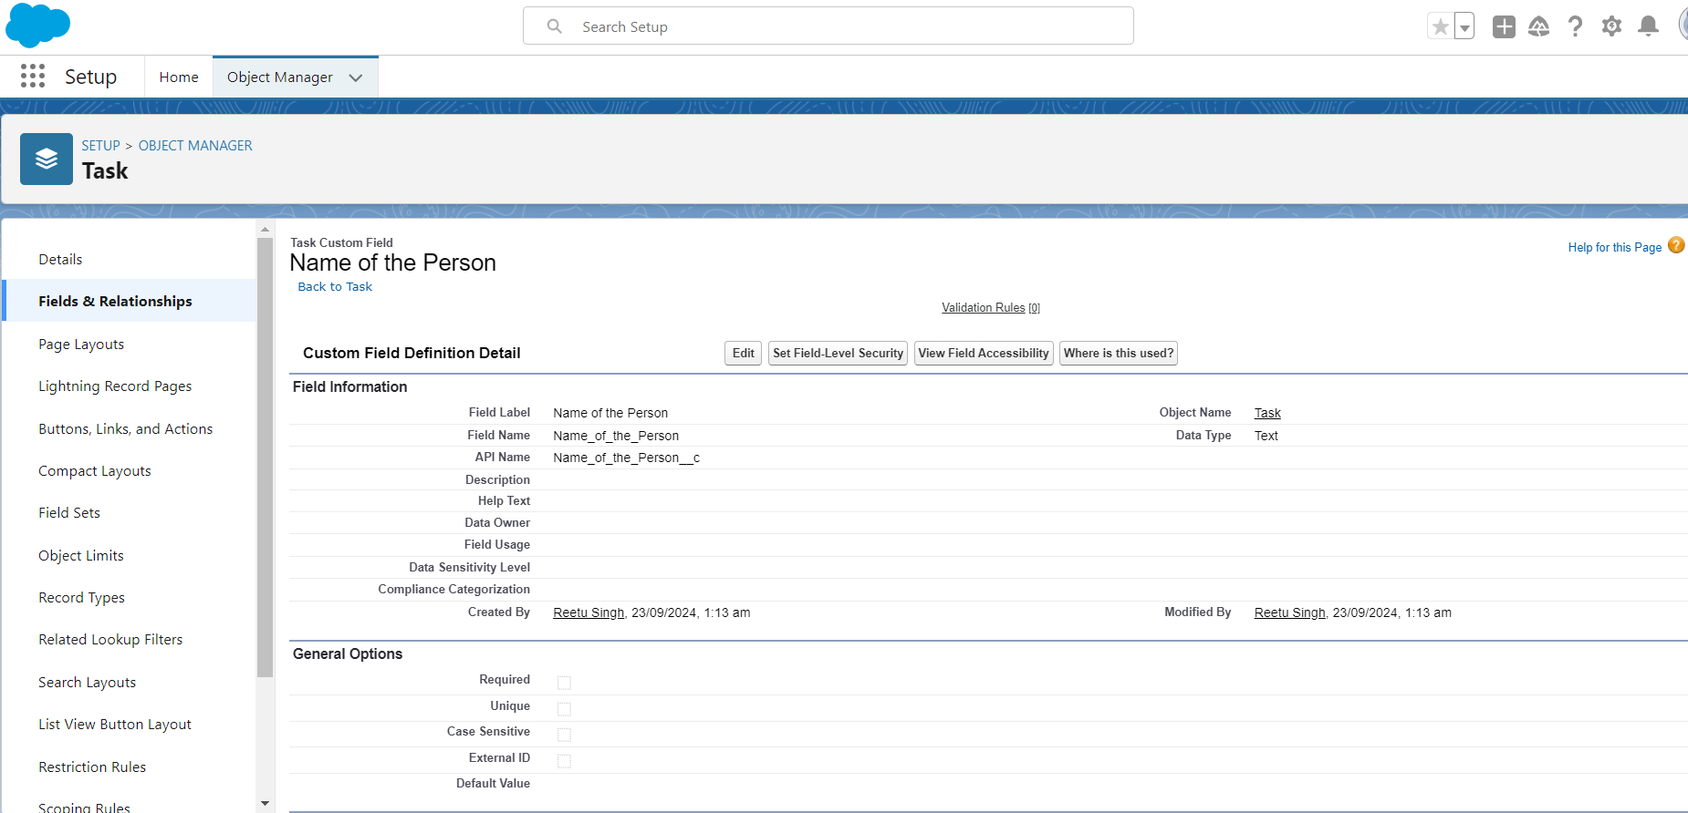

**Food Category** 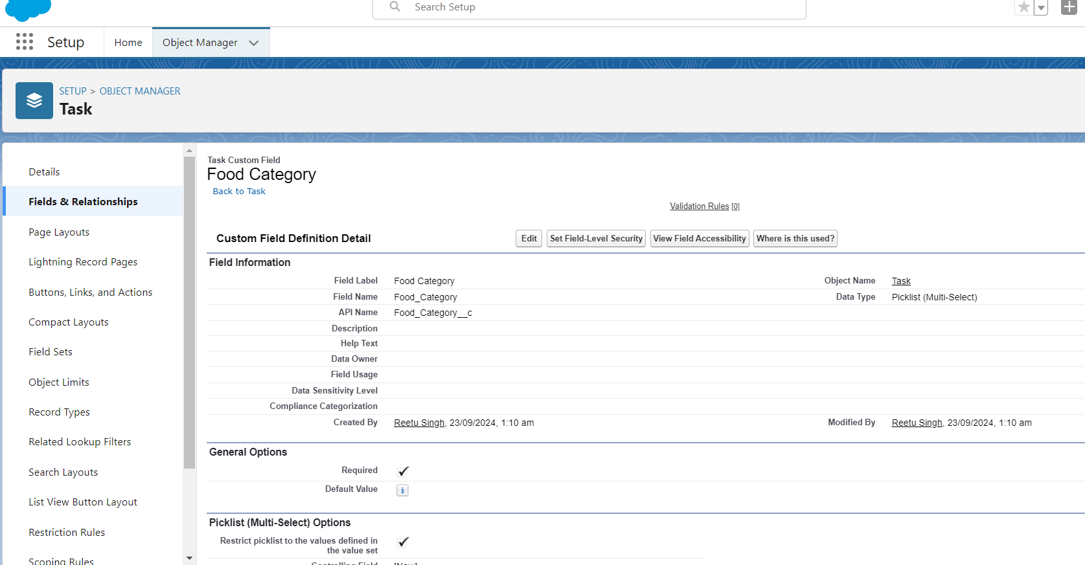

**Number of People Served**

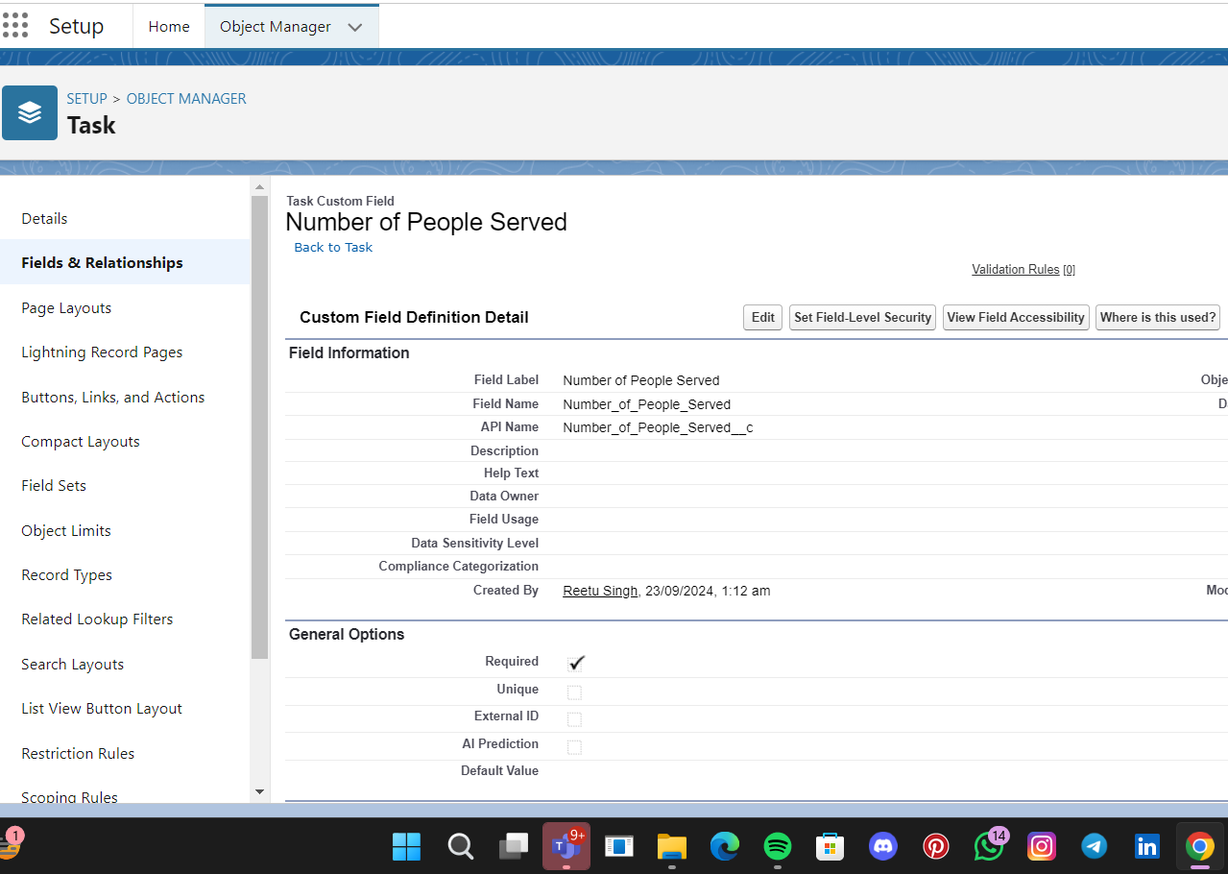

**Date**

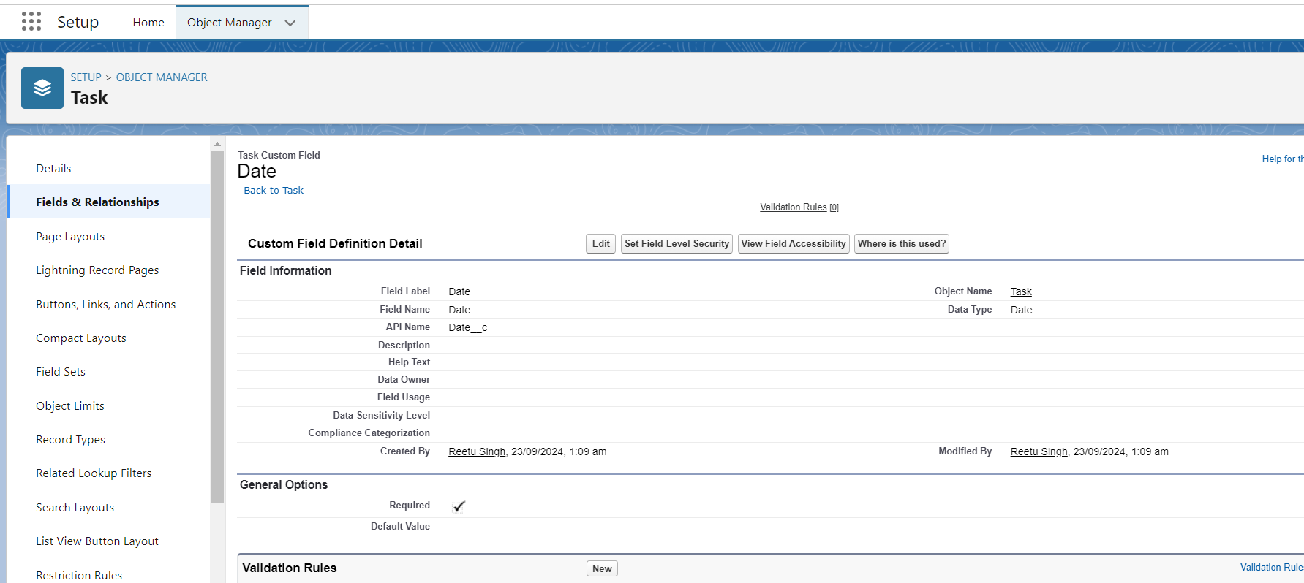

**Task ID**

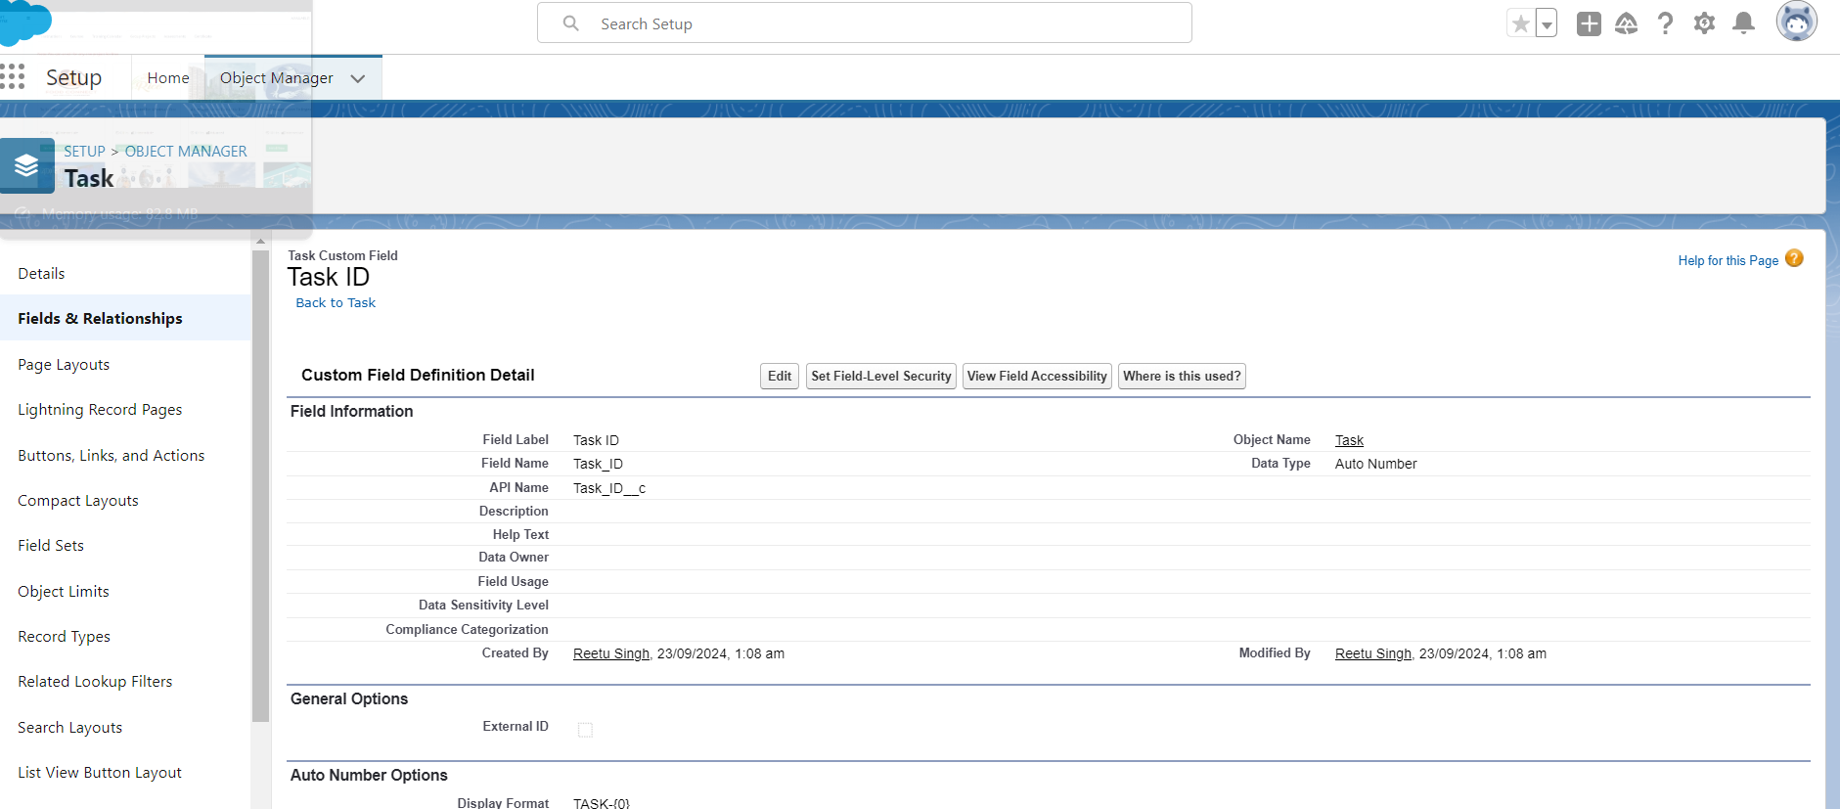

**Creation of Fields for the Execution Details Object**

**Volunteer**

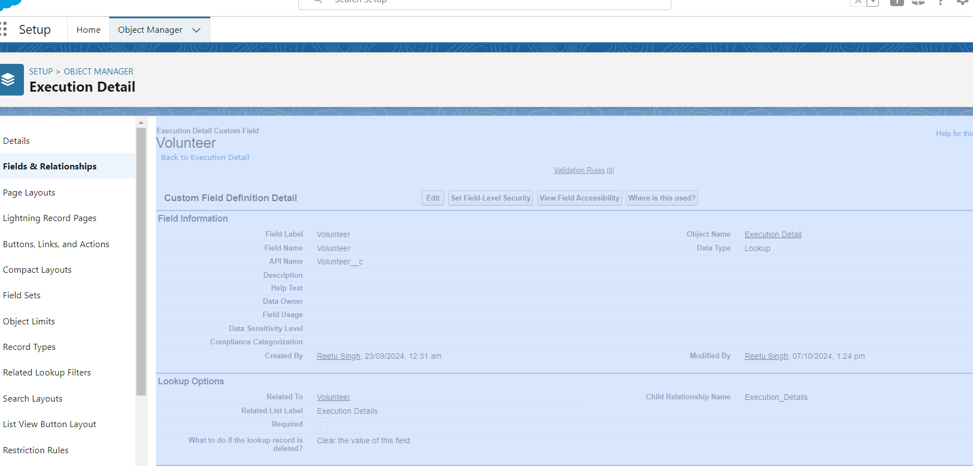

**Task**

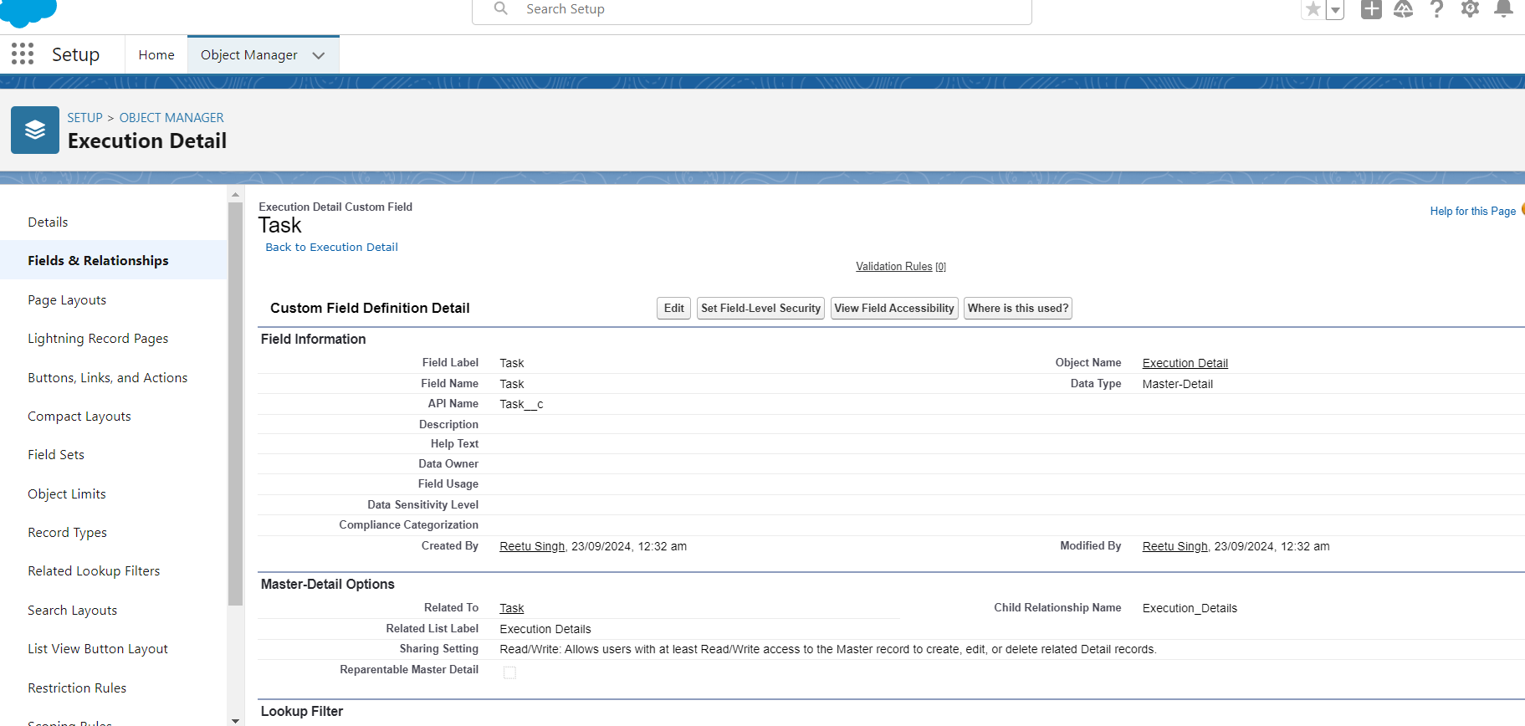

**6) Flows**

**What is a Flow?**

Flows are automation tools that allow users to create complex business processes and workflows using a visual interface. They can automate tasks, guide users through steps, and integrate with other systems.

**Flow to Create a Record in Venue Object**

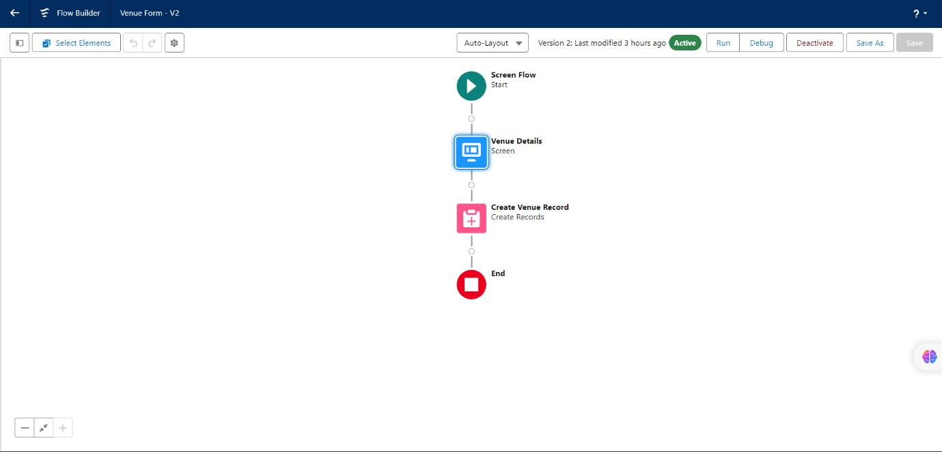

**7) Trigger**

**What is a Trigger?**

A trigger is a piece of Apex code that executes before or after specific database events on objects, such as insertions, updates, or deletions. Triggers are used to perform custom actions or enforce business rules.

**Trigger Code**

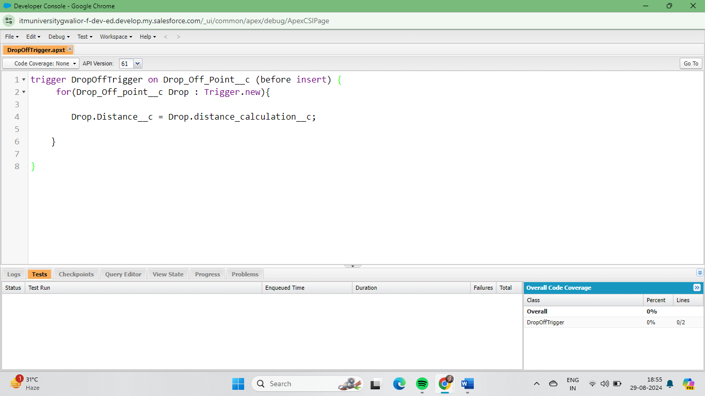

**8) Profiles**

**What is a Profile?**

Profiles define a user's permissions and access settings, controlling what users can see and do within the application. They specify the objects, fields, and functions a user can access.

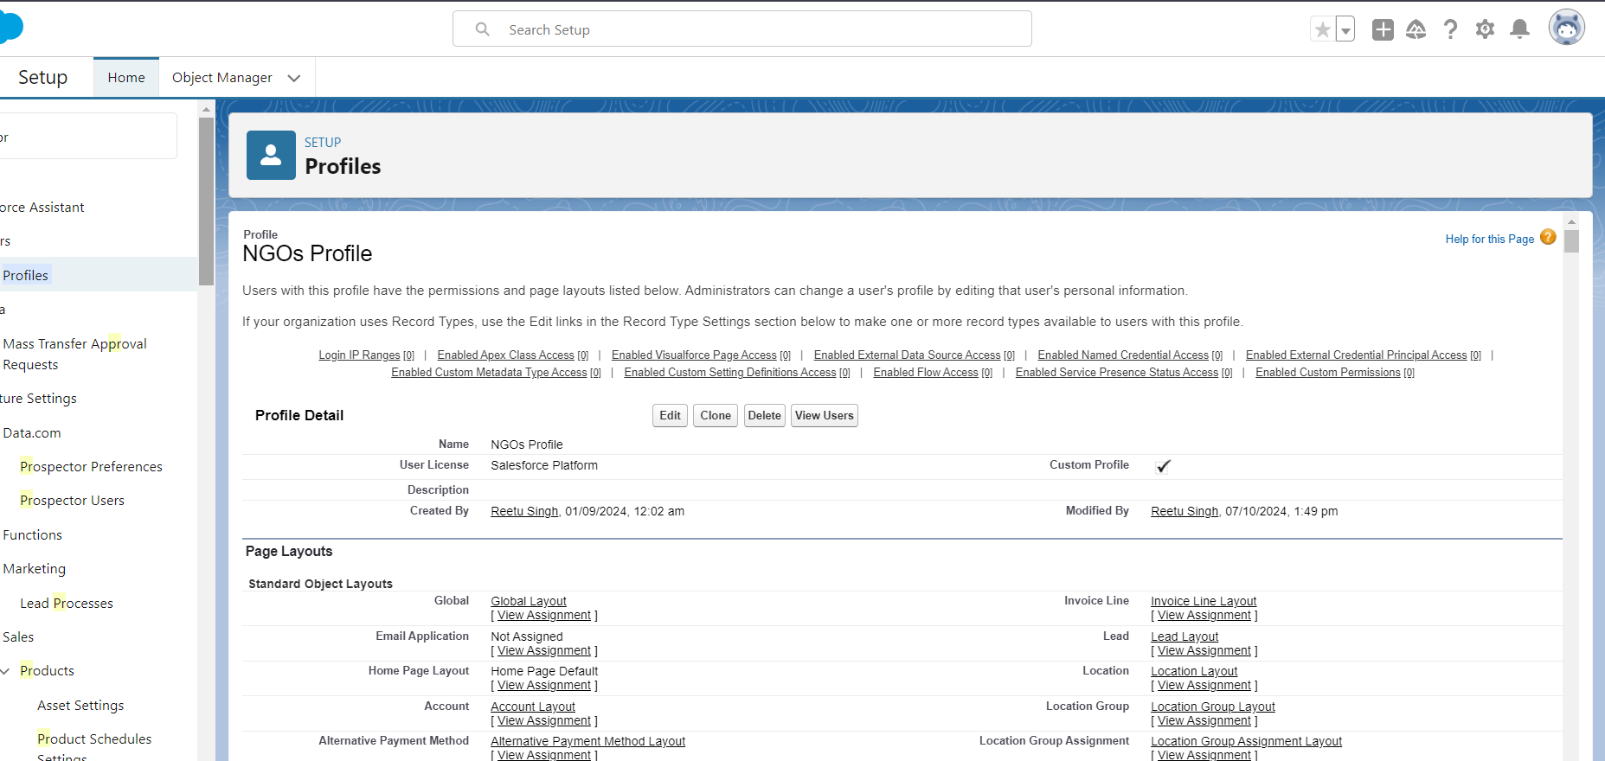

**9) Users**

**What is a User?**

Users are individuals who have login access to the Salesforce organization. Each user has a unique username, profile, and role, determining their access levels and permissions within the system.

Iksha Foundation Iksha

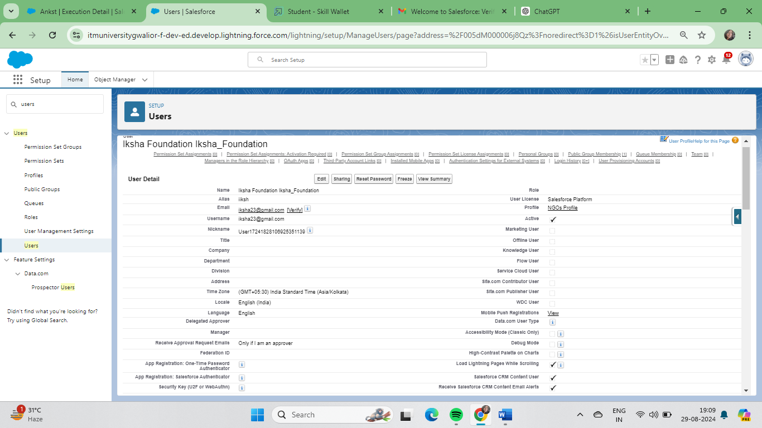

NSS

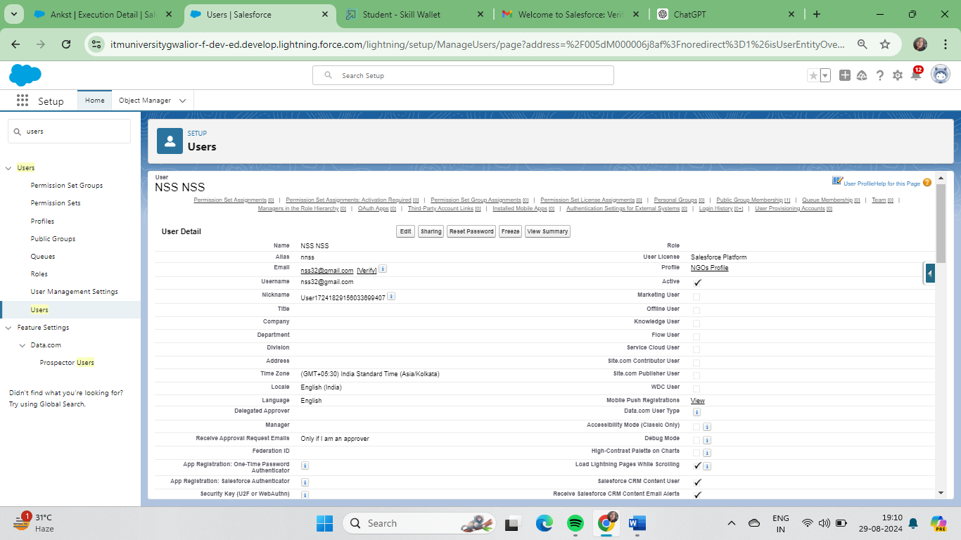

Street Cause

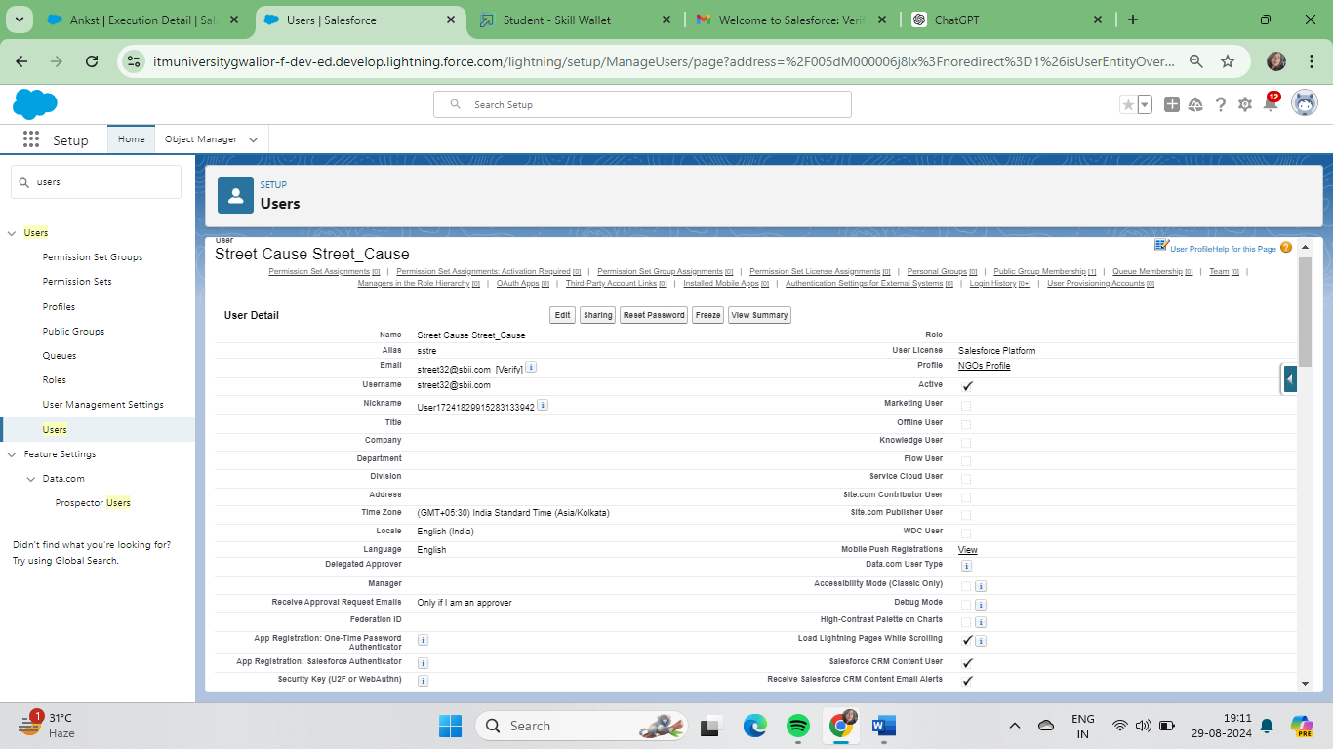

**10) Public Groups**

**What is a Public Groups?**

Public groups are collections of users, roles, and other groups that can be used to simplify sharing rules and access settings. They help manage data visibility and permissions across multiple users.

**Iksha**

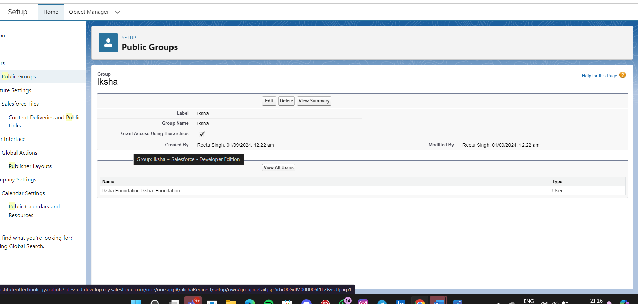

**NSS**

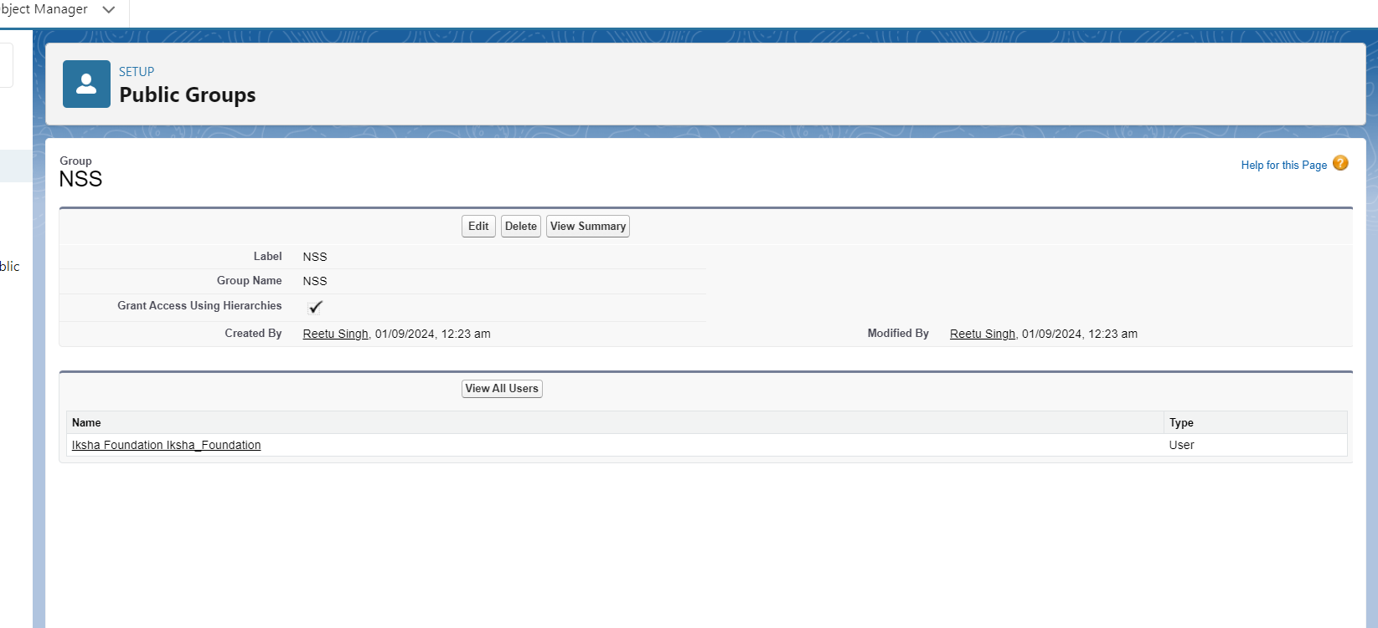

**Street Cause**

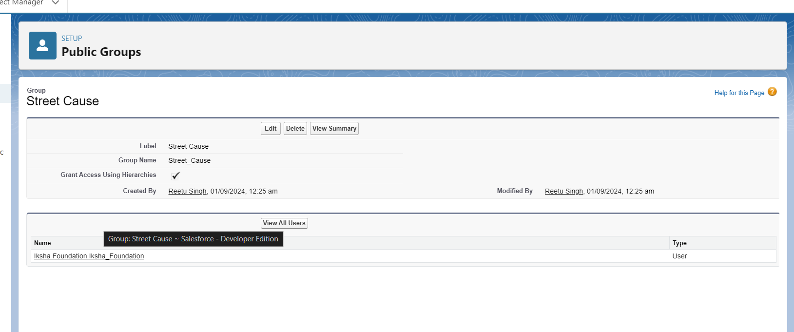

**11) Report Types**

**What is a Report Type?**

Report types define the set of records and fields available for a report. They determine which objects, and their relationships can be included, allowing users to create customized reports based on specific criteria.

**Venue with DropOff with Volunteer**

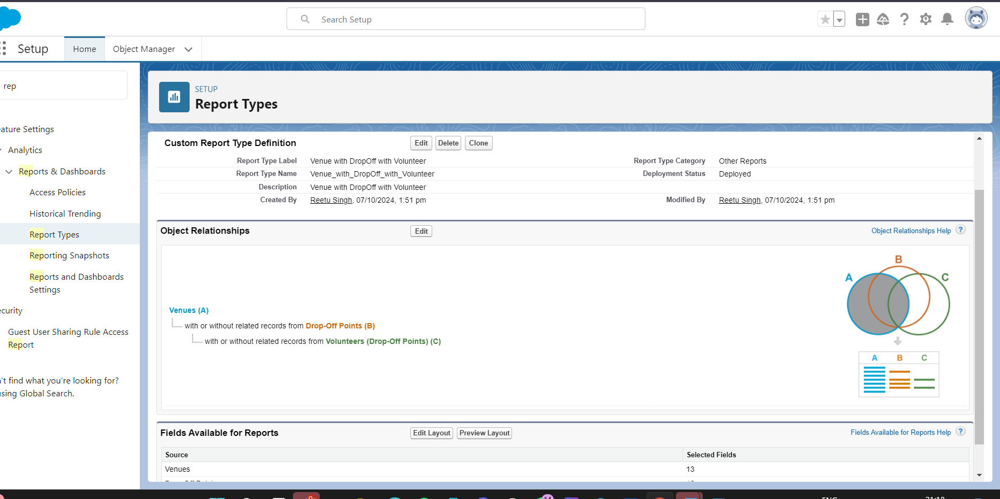

**12) Dashboards**

**What is a Dashboard?**

Dashboards are visual displays of key metrics and reports, providing a snapshot of business performance. They consist of multiple components like charts, graphs, and tables, offering insights and data visualization for decision-making.

**13) Sharing Rules**

**What is a Sharing Rule?**

sharing rules are used to extend access to records to users in public groups or roles. They allow administrators to define additional criteria for sharing records beyond what is granted by default through profiles and roles, ensuring appropriate data access across the organization.

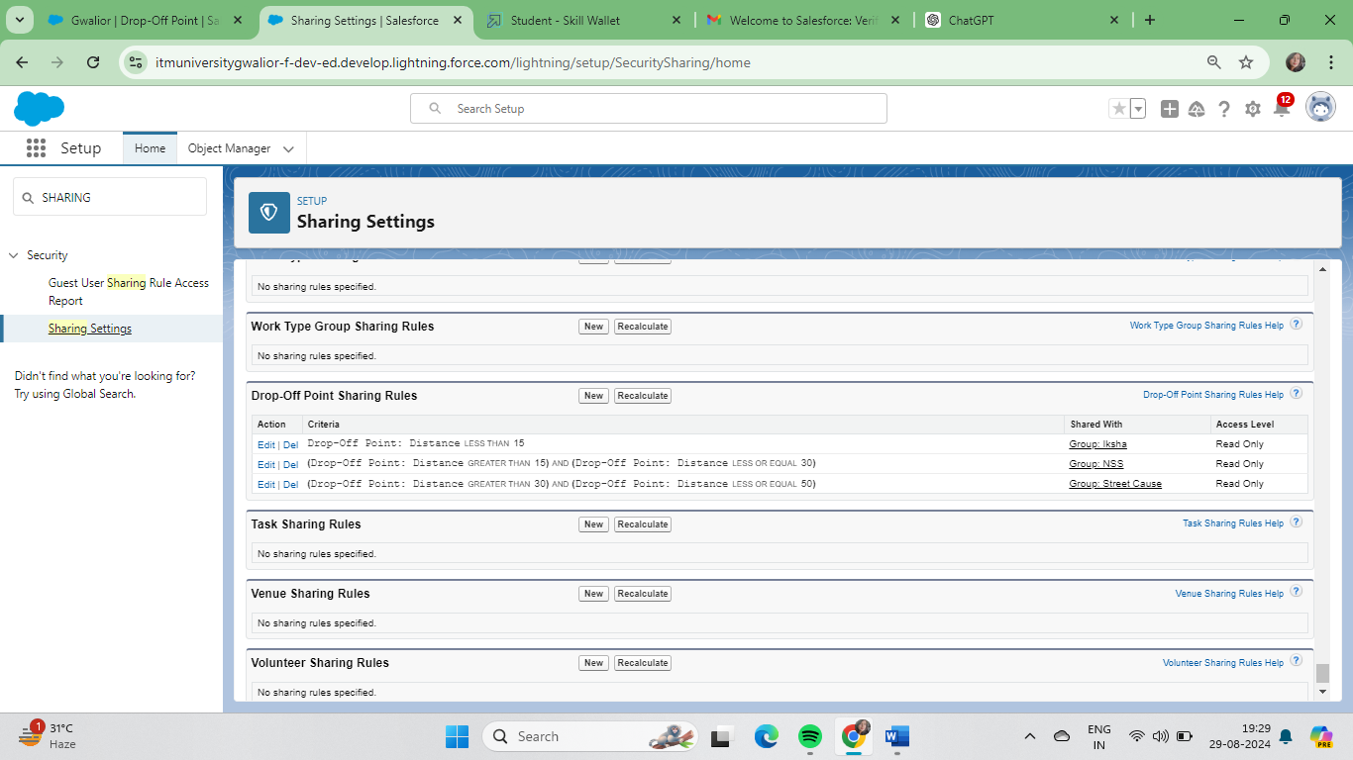

**13)**  **Conclusions**

By leveraging the Salesforce platform, the project successfully established a streamlined and transparent system for managing surplus food donations. Through efficient coordination with volunteers and timely delivery to beneficiaries, the project effectively addressed food insecurity while maximizing the utilization of available resources.

THANK YOU